1.88: a) This is a statement of the law of cosines, and there are many ways to derive it. The most straightforward way, using vector algebra, is to assume the linearity of the dot product (a point used, but not explicitly mentioned in the text) to show that the square of the magnitude of the sum 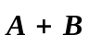is

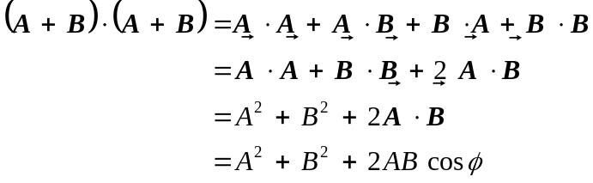

Using components, if the vectors make angles θ_{A} and θ_{B} with the x-axis, the components of the vector sum are A cos θ_{A} + B cos θ_{B} and A sin θ_{A} + B sin θ_{B}, and the square of the magnitude is

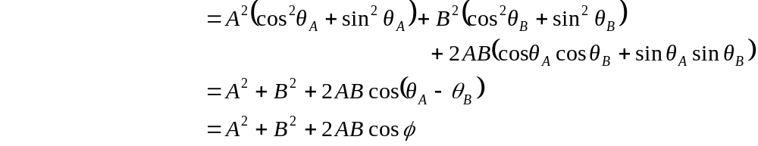

where φ = θ_{A} – θ_{B} is the angle between the vectors.

- A geometric consideration shows that the vectors 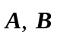 and the sum must be the sides of an equilateral triangle. The angle between 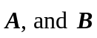 is 120º, since one vector must shift to add head-to-tail. Using the result of part (a), with 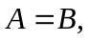 the condition is that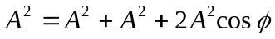, which solves for 1 = 2 + 2 cos φ, cos φ = 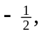 and φ = 120º.
- Either method of derivation will have the angle replaced by 180º – φ, so the cosine will change sign, and the result is 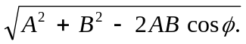
- Similar to what is done in part (b), when the vector difference has the same magnitude, the angle between the vectors is 60º. Algebraically, is obtained from 1 = 2 – 2 cos φ, so cos φ = and φ = 60º.

